16 Performance History Measures for CRST & ProSpace
Commercial Range Support Tool Project
Business System Definition

Author: Bob Trewin

Date: 09/03/2006

Version: 1.0
Authority: | Janet Smith (Programme Director)
Signature:
Authority: | John Wootton (Change Manager for Commercial)
Signature:
Authority: | Danielle Coe (Range Programme Project Manager)
Signature:
Authority: | Meryl Hanlon (IT Project Manager)
Signature:
Authority:
Signature:
Authority:
Signature:

Contents
1 Management Summary 4
1.1 Products Impacted 4
1.2 Who are the Users? 4
1.3 Why is this change required? 4
1.4 As Is versus To Be 4
1.5 Scope 4
1.5.1 In Scope 4
1.5.2 Out of Scope 5
1.6 Key Assumptions 5
1.7 Current Business Process 5
1.7.1 Make Ranging Decisions 5
1.7.2 Create Merchandise Plans 5
1.7.3 Monitor Implemented Plans 5
1.8 Proposed New Business Process 5
1.8.1 Make Ranging Decisions 5
1.8.2 Create Merchandise Plans 6
1.8.3 Monitor Implemented Plans 6
1.9 Business Requirements 6
2 Proposed System Solution 7
2.1 System Architecture 7
2.2 Process Flow 8
2.3 Performance Data Calculations 9
2.3.1 Data Warehouse Calculation For CRST 9
2.3.2 Data Warehouse Calculation For ProSpace 10
3 Risks & Issues 12
Document Control 12
Change Record 12
4 APPENDIX 14
4.1 Integration Requirements 14
4.1.1 New Interfaces 14
4.1.2 New Internal Processes 14
4.1.3 Changed Interfaces 14
4.1.4 Redundant Interfaces 14
4.2 System Changes 14
4.2.1 New Attributes Required in CRDB 14
4.2.2 New Attributes Required in DW 14
4.2.3 New Tables Required in DW 15
4.3 Detailed Processing 15
4.3.1 Set Up Default Sales History Period (New Internal Process 08) 15
4.3.2 Extract Sales Parameters (New Interface 109) 15
4.3.3 Extract Store Range Groups (New Interface 113) 15
4.3.4 Extract Products (Interface 30) 15
4.3.5 Data Warehouse Event Details Load 15
4.3.6 Data Warehouse Store Range Group Details Load 16
4.3.7 Data Warehouse Product Details Load 16
4.3.8 Data Warehouse Calculation For CRST 16
4.3.9 Data Warehouse Calculation For ProSpace 16
4.3.10 CRST Sales Load 16
4.3.11 ProSpace Sales Load 16

Management Summary

Products Impacted
- Commercial Range Database (CRDB)
- ProSpace
- Data Warehouse (DW)

Who are the Users?
- Commercial buyers use product performance data to support ranging decisions.
- Merchandisers use product performance data to:
- Calculate product space allocation when creating new merchandise plans.
- Monitor Level Run Down and support re-calculation of product space allocation on merchandise plans.

Why is this change required?
- To create a common source and give consistency across product areas to the performance data used to support ranging decisions.
- To give flexibility in the choice of history periods for performance data.
- To provide a sales feed to support implemented plans that will respond dynamically to the creation of new store clusters, providing a flexibility that the current sales feed based on a pre-defined set of region codes cannot give.

As Is versus To Be

As Is | To Be
- A temporary solution provides sales history to CRST based on a rolling 52 weeks for all ranging events. | - Commercial users will choose between a rolling 52 weeks or a fixed performance history period with user-defined start and end dates.
- CRST has no performance data apart from sales. | - CRST will have performance data based on waste, margin and other key elements.
- To monitor implemented plans, ProSpace uses a set of 7 sales feeds aggregated by a fixed set of store types and region codes. | - ProSpace will receive a file of sales data for each implemented merchandise plan, based exclusively on sales in stores in the cluster to which the plan relates.
- ProSpace receives sales history from MH based on a rolling 52 weeks. | - ProSpace will receive forecast sales data for plans in progress with each range that is sent from CRST.  - ProSpace will receive sales data from the Data Warehouse for each implemented plan based on the history period (rolling or fixed) which was used when the range was planned.

Scope

In Scope
- Merchandising groups that have been rolled out to CRST.
- Authorised store merchandising groups.
- Changes required to:
- Commercial Range Database (CRDB)
- Data Warehouse (DW)
- ProSpace
- Commercial Range Support Tool (CRST)

Out of Scope
- Merchandising groups that are ranged through CW.
- Forecast sales feeds for WIP and Pending plans
- Sales feeds to SSPOGs

Key Assumptions
- The issue of zero sales will be addressed in later work.
- Promotional sales will be addressed in later work.

Current Business Process

Make Ranging Decisions
- Commercial buyers use CRS reports and performance data from other sources to support their ranging decisions. Individual preferences and varying degrees of diligence mean that the quality and consistency of data may vary both over time and between product areas. To support testing of the new range and merchandising processes, a feed of sales data (with no other supporting performance measures) has been developed, which will be used by both Commercial and Merchandising.

Create Merchandise Plans
- ProSpace receives a weekly feed of sales data, based on a rolling 52 week average, by merchandising group, from MH for each of the following store groupings:
Interface | MH Region Code Matching | Plan Region Code Matching
- Non-Metro | n/a | P, A, C, O
- Metro | n/a | M, F, H
- ROI | n/a | R
- Scottish | S, H, Y | S
- N. Ireland | N | N
- Extra | D, Y | D, Y
- Express | E | E

- The first three feeds are based on store type attributes held in MH. Feeds 4 to 7 are based on store merchandising group region codes obtained from GR.
- These interfaces are mapped to plans on the basis of the region codes shown above.

Monitor Implemented Plans
- The same interfaces that are used for creating new plans are mapped to implemented plans on the basis of the region codes shown above.

Proposed New Business Process
This will apply to merchandising groups ranged through CRST. Merchandising groups still ranged through CW will continue to be supported by the current business process.

Make Ranging Decisions
- Commercial users will be given performance data based on a rolling 52 weeks. They will be able to choose, as an alternative, to use performance data based on a fixed historical period that they define.

Create Merchandise Plans
- The forecast sales created in CRST by Commercial will be interfaced to ProSpace. Plan calculations will be based on the same data that supported ranging decisions.

Monitor WIP Plans
- There will be no regular sales feed for WIP plans. Updated forecast sales will only be sent from CRST to accompany changes to the range.

Monitor Implemented Plans
- For implemented plans that have been ranged through CRST, ProSpace will receive a sales feed based on the historical period defined when the range was created.
- No sales will be available during week zero.

Business Requirements
MoSCoW Key:
M = | Must have system-supported capability
S = | Should have system-supported capability for a later phase of the project
C = | Could have system-supported capability for a later phase of the project
W = | Won’t have system-supported capability

Ranging and Merchandise Planning
- Performance measures required are:  - Sales value (inc. VAT)  - Sales value (ex. VAT)  - Sales units  - Sales weight  - Waste value  - Margin value (profit) | M
- Commercial users will be provided, by default, with performance data based on a rolling 52 week average.
- Commercial users will be able to change the historical period from rolling to fixed and, if they do, specify the start and end weeks (inclusive) of the fixed period. | M
- Commercial users will not be able to change the number of weeks from 52 for a rolling historical period. | M
- Performance data will be expressed in CRST for each product as the average per week per store over the defined historical period. | M
- Weeks with zero sales will be excluded from the calculation. Similarly, calculations of other performance measures which register zero in any week will exclude that week. | M
- Each performance measure will be calculated independently of the others i.e. a week with zero sales will not influence the calculation of average margin. | M
- The sales feed from the Data Warehouse to CRST will be available in the Data Warehouse for the business to query for WIP plans. | M
Monitoring Implemented Plans
- Sales history for implemented plans will be based on the history period defined by Commercial when creating the range. | M
- Sales history will be tailored exactly for each plan i.e. sales will be aggregated only from stores in the store cluster and with the range class that the plan relates to. | M
- If the history period is Rolling, the sales average will always be for the last 52 weeks. | M
- If the history period is Fixed, the sales period will start from the week the plan is implemented to the week prior to the current (inclusive), i.e. each week, the history period will be increased by one week. | M
- Weeks with zero sales will be excluded from the calculation. | M
- Data for implemented plans must be available in ProSpace by 9:00am each Monday. | M

Proposed System Solution

System Architecture

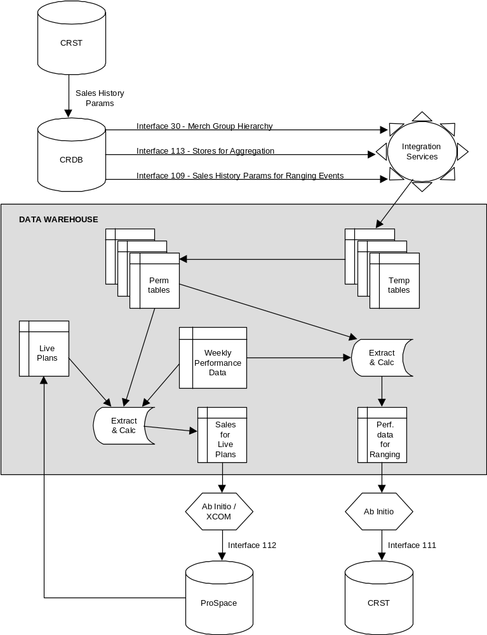

System Process Flow
The overnight processing flow for a single range event is illustrated by the following diagram:
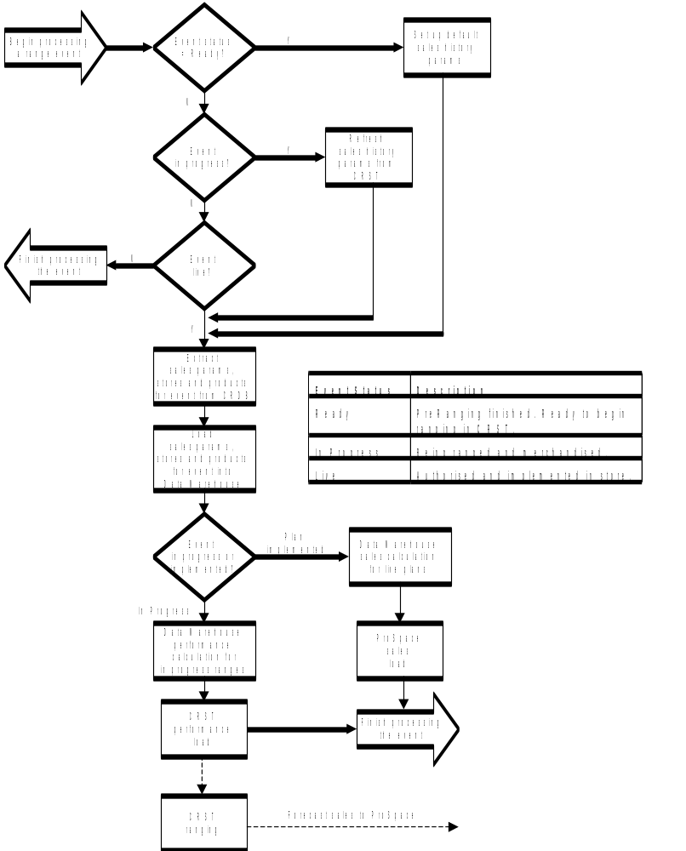

Notes on Process Flow
- For an in progress event, the range event status is set to ‘Ready’ (in Pre-Ranging or RSM Schedule application).
- That night, the first job to run in the overnight batch schedule for CRDB will populate the sales parameters on the MERCH_GRP_IN_EVENT table with a rolling 52 weeks for all events with a status of ‘Ready’.
- Details of stores (and their range class for the event) and products for all in progress and live range events are interfaced to DW, along with their sales parameters. Data Warehouse will load this data into new tables (see below).
- For an in progress event:
- DW will extract and aggregate average sales (and other measures) per product for each store range group / space break for the event.
- This data will be loaded into CRST.
- Commercial users will be able to change the sales history period parameters through a CRST workbook.
- Forecast sales will accompany every range that is sent from CRST to ProSpace.
- For an implemented generic merchandise plan:
- DW will extract and aggregate average sales per store for each product on the plan, only including those stores in the plan’s store range group.
- This data will be loaded into ProSpace.
- The sales history period parameters will remain unchanged (i.e. as they were for the event when the range was authorised).

Performance Data Calculations

Data Warehouse Calculation For CRST
A file will be produced in the following format:

Field
Event_ID
Store_Range_Group_ID
Space_Break_Code
TPNB
Average Weekly Sales Value (inc.VAT) This Year
Average Weekly Sales Value (inc.VAT) Last Year
Average Weekly Sales Value (ex.VAT)
Average Weekly Sales Units
Average Weekly Sales Weight
Average Weekly Number of Stores (sales)
Average Weekly Waste Value
Average Weekly Number of Stores (waste)
Average Weekly Margin Value
Average Weekly Number of Stores (margin)
Launch / Promo Flag

The basis for the extract logic is as follows:
- Extract data for every Event that is not yet live (Live_Ind = 0).
- For each Event / store range group / space break / performance measure:
- Extract weekly performance data for each product on PRODUCT_FOR_EVENT for each store on STORE_FOR_EVENT according to the history period parameters defined on EVENT. Keep a count of the number of datapoints (store/week combinations with non-zero data) and also a count of the number of weeks with sales (i.e. weeks in which there were sales in at least one store).
- For each product, roll up performance data and divide the total by the number of datapoints to give the average per store per week.
- Divide the number of datapoints by the number of weeks with sales to give the average number of stores per week.
- Multiply the average for the performance measure by the average number of stores per week to give the average for the store range group / space break.
NB These calculations meet CRST’s requirements. CRST will export forecast sales at the level required for ProSpace (average per store per week).
Example
There are 5 stores with the same space break in a store range group which have the following sales for a product over a 4-week period.
Store | Week 1 | Week 2 | Week 3 | Week 4 | Week 5 | Week 6 | Week 7 | Total
Store A | 20 | 10 | 50 | 0 | 20 | 20 | 30 | 150
Store B | 0 | 0 | 0 | 0 | 30 | 20 | 20 | 70
Store C | 70 | 30 | 20 | 0 | 0 | 0 | 0 | 120
Store D | 50 | 40 | 80 | 0 | 10 | 40 | 40 | 260
Store E | 30 | 20 | 20 | 0 | 20 | 10 | 20 | 120
 |  |  |  |  |  |  |  | 720
Total sales = 720
Total datapoints = 24
Total weeks with sales = 6
Average weekly sales per store per week = 720 / 24 = 30
Average number of stores per week = 24 / 6 = 4
Average weekly sales for the store range group / space break = 30 * 4 = 120

Data Warehouse Calculation For ProSpace
A file will be produced in the following format:

Field
Merch_Grp_Code
Merch_Region_Code
Space_Break_Code
TPNB
Average Weekly Sales per Store

Average weekly sales will be expressed either in units or weight. If both exist for the same product, units will be used.
The basis for the extract logic is as follows:
- Extract data for every live Event (Live_Ind = 1).
- Products on the implemented live plan will be the driver for sales. Products on PRODUCT_FOR_EVENT table must not be the driver, since plans may not exactly match ranges and stores may sell products outside their range.
- For each live Event:
- Find all the stores for a plan by matching:
- the Event Id from EVENT to the Event Id on STORE_FOR_EVENT and the Event Id on the Plan table
- Merch_Grp_Code, Space_Break_Code and Merch_Region_Code from STORE_FOR_EVENT to HDR_PLAN_NAME chars 1-3, HDR_PLAN_NAME char 4 and HDR_PLAN_NAME char 6.
- Select the matching plan with the most recent YEAR/WK
- If plans have been created for more than one equipment type, there will be more than one match. However, each plan should have exactly the same products, so the list of products can be sourced from any of the matching plans.
- Match key fields on the Plan table to the corresponding key fields on Product Summary table to identify products on the plan.
- Extract weekly sales for each product on the live plan for each matching store on STORE_FOR_EVENT according to the history period parameters defined on EVENT. If the history period is Rolling, the last 52 weeks will be used. If the history period is Fixed, data from the Event_Yr_Wk to the latest (inclusive) will be used.
- If no stores were found that match the plan, insert a row with a zero sales value for each TPNB on the plan.
- If no sales are found for any TPNB, insert a row with a zero sales value for the TPNB.
- The method of calculation for average weekly sales per store will be the same as for CRST performance data.

Risks & Issues
Risk / Issue | Resolution | Risk / Issue
Service levels from the Data Warehouse cannot be guaranteed at all times. There is immense pressure on processing capacity, particularly on Sunday nights, and system failures occasionally occur. | The Data Warehouse will endeavour to provide the best service possible. | Medium Risk
Extraction of data from a history period greater than 52 weeks may have a detrimental effect on performance and may jeopardise the Monday morning deadline for ProSpace. | History periods greater than 52 weeks should be treated with caution. | Medium Risk
Products sold by weight at the checkout have their sales registered as units. Each sale is a single unit. | Change required to sales capture systems. | Issue
In the calculation at the end of week –1, sales for live plans will be based on the plans that are still active in stores, not the new live plans in ProSpace. These sales, when applied to the live plans in ProSpace, will either not match the plan (i.e. the plan will have zero sales for all products) or will be inaccurate. | This problem is unavoidable because ProSpace only supports one set of live plans. Merchandisers and stores must be aware that sales for live plans in week zero will be inaccurate. | Issue

Document Control
Project: | CRST
Document Title: | Business Requirements Definition
Document Location: | Ranging Workroom
Distribution: | Janet Smith | Range, Space & Merchandising Program Director
 | Danielle Coe | Range Programme Project manager
 | Adam Harrison | Project manager, IT
 | Meryl Hanlon | Project manager, IT
 | Sue Leach | Business Analyst, IT
 | Yinka Aiyetigbo | Analyst Programmer, IT
 | Range Team, IT

Change Record
Date | Author | Change Description | Version
01/12/2005 | Bob Trewin | Initial draft | 0.1
06/12/2005 | Bob Trewin | Following review with Merch IT and DW | 0.2
07/12/2005 | Bob Trewin | Following review with Ian McLeod | 0.3
13/12/2005 | Bob Trewin | Update interface numbers | 0.4
15/02/2006 | Bob Trewin | Following review with Danielle Coe. Restructure to move technical information to Appendix.  Inclusion of Event Id on plans to guarantee accurate matching. | 0.5

APPENDIX

Integration Requirements

New Interfaces
Interface | Source | Target | Frequency
108 – Aggregation Parameters | CRST | CRDB | Daily
109 – Aggregation Parameters | CRDB | DW | Daily
111– Aggregated Performance Data | DW | CRST | Daily
112 – Aggregated Sales for Implemented Plans | DW | ProSpace | Weekly
113 – Stores for Aggregation | CRDB | DW | Daily

New Internal Processes
Process | Location | Frequency
08 – Set Default Sales History Params | CRDB | Daily

Changed Interfaces
Interface | Source | Target | Change Detail
30 – MG Hierarchy | CRDB | CRST/DW | Include DW as destination
GRL.#JSR0070.PROSPACE.EXTRACT | ProSpace | GR/DW | Include Event Id on Plan Detail

Redundant Interfaces
Interface
84 – Event / Cluster / Store
85 – 52 Weeks Average Performance
37 – Aggregated Performance Data

System Changes

New Attributes Required in CRDB
Additional columns on MERCH_GRP_IN_EVENT
Fixed_Rolling_Flag (‘F’ or ‘R’)
Rolling_Weeks (default = 52)
Fixed_Start_Yr_Wk
Fixed_End_Yr_Wk

New Attributes Required in DW
Additional column on Plan table
Event_Id

New Tables Required in DW
EVENT
(PK) Event_ID
(PK) Merch_Grp_Code
Live_Ind
Fixed_Rolling_Flag (‘F’ or ‘R’)
Rolling_Weeks
Fixed_Start_Yr_Wk
Fixed_End_Yr_Wk

STORE_FOR_EVENT
(PK) Event_ID
(PK) Merch_Grp_Code
(PK) Store_Range_Group_ID
(PK) Space_Break_Code
(PK) Store_No
Merch_Region_Code

PRODUCT_FOR_EVENT
(PK) Event_ID
(PK) TPNB

Detailed Processing

Set Up Default Sales History Period (New Internal Process 08)
See specification for Int_Proc 08 Set Default Aggregation Period Parameters.

Extract Sales Parameters (New Interface 109)
See specification for Interface 109 Aggregation Period Params.

Extract Store Range Groups (New Interface 113)
See specification for Interface 113 - Stores for Aggregation.

Extract Products (Interface 30)
See specification for Interface 30 Merchandising Hierarchy.

Data Warehouse Event Details Load
This will take place in two stages:
- Data from Interface 109 will be loaded into a temporary table by Integration Services.
- Data Warehouse will transfer the data from the temporary table to a permanent EVENT table, dropping the table and recreating it from scratch each day.

Data Warehouse Store Range Group Details Load
This will take place in two stages:
- Data from Interface 113 will be loaded into a temporary table by Integration Services.
- Data Warehouse will transfer the data from the temporary table to a permanent STORE_FOR_EVENT table, dropping the table and recreating it from scratch each day.

Data Warehouse Product Details Load
This will take place in two stages:
- Data from Interface 30 will be loaded into a temporary table by Integration Services.
- Data Warehouse will transfer the data from the temporary table to a permanent PRODUCT_FOR_EVENT table, dropping the table and recreating it from scratch each day.

Data Warehouse Calculation For CRST
See Performance Data Calculations above.

Data Warehouse Calculation For ProSpace
See Performance Data Calculations above.

CRST Sales Load
See specifications for CRST batch processes.

ProSpace Sales Load
See specification for Interface 112.

Ref: BSD for ProSpace Data Warehouse Load v 1.0 by David Gould, 30th June 2004

